**State of Colorado - Weather Analysis**

Matthew W Schnorr

Department of Data Science – SNHU

DAT 530 – Enterprise Data Management

Submitted to Paul Simpson

4/25/2021

**State of Colorado Weather Analysis**

**Background and Audience Analysis**

The purpose of this presentation is to use historical storm data from the state of Colorado as a three-prong tool to help drive knowledge and future action regarding weather within the state. The information gathered will be focused in three areas to three separate audiences. When working in conjunction, the three focuses will help provide a safer state to live in. As with any information, it must be tailored to each audience individually as they will all have varying levels of education, need, and interest on the topic.

The first area of focus (in no specific order) will be financial. I will be presenting an analysis as a high-level presentation to the state budget office. This will allow them to have historical information to base future financial budget decisions, setting aside appropriate reserves for things such as storm prevention, maintenance, and repair. Allowing them to allot the appropriate resources will ensure they have enough to fulfill these tasks, but not setting aside more resources than necessary that could better benefit other areas of the state. The audience will be educated from a financial perspective regarding storms based on past political experiences but will not have an in-depth knowledge of storm operations. Therefore, I will focus primarily on an in-depth financial level with this group.

Conversely, the second audience will be highly educated in all things meteorological and will this require a more granular interface and data set specific to the weather itself. This group will be the Colorado State Emergency Management Agency. To them, they will need to be able to understand great details of storms, including size, scope, intensity, and location. This will help them allocate the appropriate resources such as equipment and personnel to the appropriate locations. Again, the goal is efficiency, so I plan to provide them an interactive dashboard where they can drill down to any level of detail needed to assess the situation at hand.

Finally, the largest audience will be the public at large, the citizens of Colorado. For them, I want to provide a pamphlet that will contain a very high level of information on varying storms they may encounter and how best to behave in various weather situations. This information will be short and aimed at providing best practices and tips on actions they can take when the situation calls for it, such as hailstorms, tornadoes, or floods. Their interest will generally be minimal so providing something short in a proactive approach should maximize the intended benefit of safety. Again, this audience’s knowledge of weather will be fairly limited in comparison to the experts, so a pamphlet or handout will be a sufficient medium for this interaction.

When merged, an educated group of citizens with a prepared emergency services team that are provided with a sufficient budget from the state government will help ensure minimized long-term, weather related issues. As we all know, weather is one of the uncontrollable areas of life, so proactive preparation is one of the few controllable variables we have in the entire process. Using historical data is the best approach to predicting future activities, when collected, reviewed, and presented efficiently.

**Platform for Delivery and Visual Displays**

Each group is going to require a different medium of presenting the information and the lens/focus of the information for each group will be different. As the budget office is mostly focused on monetary decisions, the goal is to include the information where money is the main component as well as injuries and deaths as they government could possibly face lawsuits if they did not act appropriately during storms. A few graphs and tables for them should be appropriate to deliver the message. A graph on deaths and injuries by month could show them when the risk is the greatest from a humanity perspective. Also, a table showing the cost of both property damage as well as crop damage by storm type would help show both individual and total expected costs. Finally, a graph on total cost per county could help them determine where to appropriate funds.

For the EMA experts, an interactive dashboard is critical, which can be accomplished through Tableau. They need to be able to do things like filter on storm types, months of storms, locations, length of storms, intensity of storm types, and so forth. My plan for this group is an interactive dashboard that comprehensively filters on the five largest storm types by cost. The five most impactful storm types are floods (regular and flash), hail, thunderstorm winds, and tornadoes in the state of Colorado. If they can see storm paths by type in one geographic map, they can determine when and where to place their resources. The same goes for comparing storm type with beginning location. Finally, a third interactive piece detailing average length of storm by storm type each month can help them plan.

For the public, a pamphlet with best practices for possible storm types would be useful. Some of the visuals could focus on what months experience each storm type as well as a graph showing what storm types cause the most damage, injuries, and deaths. Also, some statistics and directions in a word format from a high level could give them information on what types of storms they need to plan and prepare for and which are less concerning/happen less frequently.

The data we are focused on is robust enough to provide all these visuals, tailored to each specific group and tailored to the specific focus of each. The best way to connect is to determine what is most impactful to each group, then construct your deliverables with those goals in mind. Here, a variety of tools such as power point, Tableau, and even a word document generated pamphlet will help me accomplish the task at hand.

**Visual Elements and Formatting Guidelines**

Regarding granularity and sophistication, the brochure for the public will be the least granular and sophisticated, mostly consisting of high-level facts and best practices for storm preparedness. This will include mostly instruction and simple, easy to understand visuals. I will use larger fonts and more vibrant colors to call attention to important points into the brochure, including some breakout facts and figures as well as bulleted lists and categorical and possibly spatial visuals where needed. I will also provide a website and phone number to where the public can contact representative weather experts.

The state budget office will require a bit more complexity and granularity than the public brochure. The focus for this audience will be to provide more facts and figures as well as more in-depth graphs. These will be focused on costs and counties, which is the financial and geography areas of concern. Some combination of color as well as well-defined axis, labels, titles, and legends will provide more granularity than the public, but will also not be so in depth that the focus is blurred.

Finally, the interactive dashboard prepared for emergency responders will require the highest level of complexity, sophistication, and interactivity of the three mediums. Whereas the prior two audiences can have static data, this group requires the ability to interact with the information to determine what-if scenarios as well as filtering for certain criteria they are attempting to focus on. The inter connectivity of storm paths by type, those that cause the most damage, and average storm time will allow the workers to see what has happened historically with some of the future forecasted storms. Training the users to use the dashboard to its full capability will be the most challenging piece as not everyone is analytical or technologically savvy in that profession. So, providing a resource person to assist in utilizing the tools and helping to analyze would be a critical piece in successful implementation.

**Plots and Graphs**

Audience – State Budget Office

Examples of such graphics to be included in the power point presentation for the state budget office are displayed below. Listing both historical damage costs and hardest hit counties in declining order allows the audience to generate priorities in budgeting. Adding the visual enhances context of the numerical table and lets the officials see a comparison between counties and the financial impact each has faced in the past. The red color also immediately draws the eye to biggest areas of need.

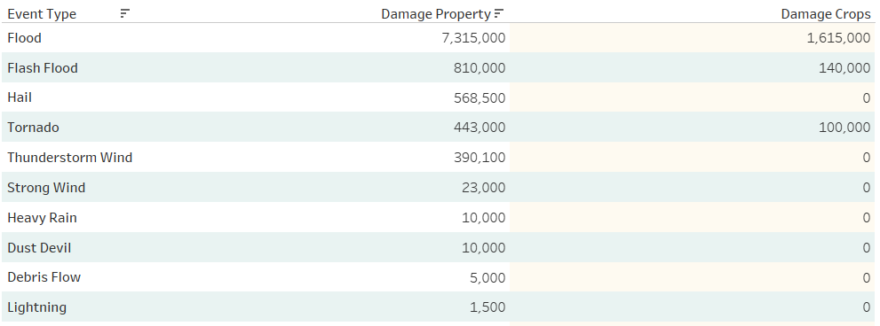

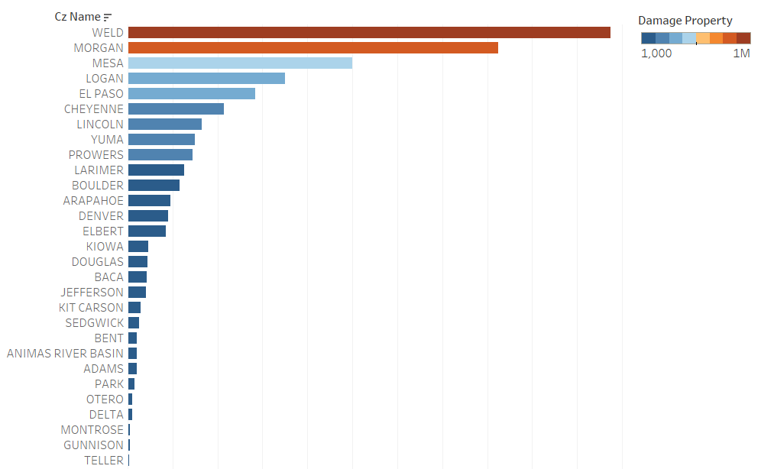

Audience – Emergency Management Agency

The initial view of the dashboard that will be provided to the Colorado EMA appears as follows:

*Full Dashboard*

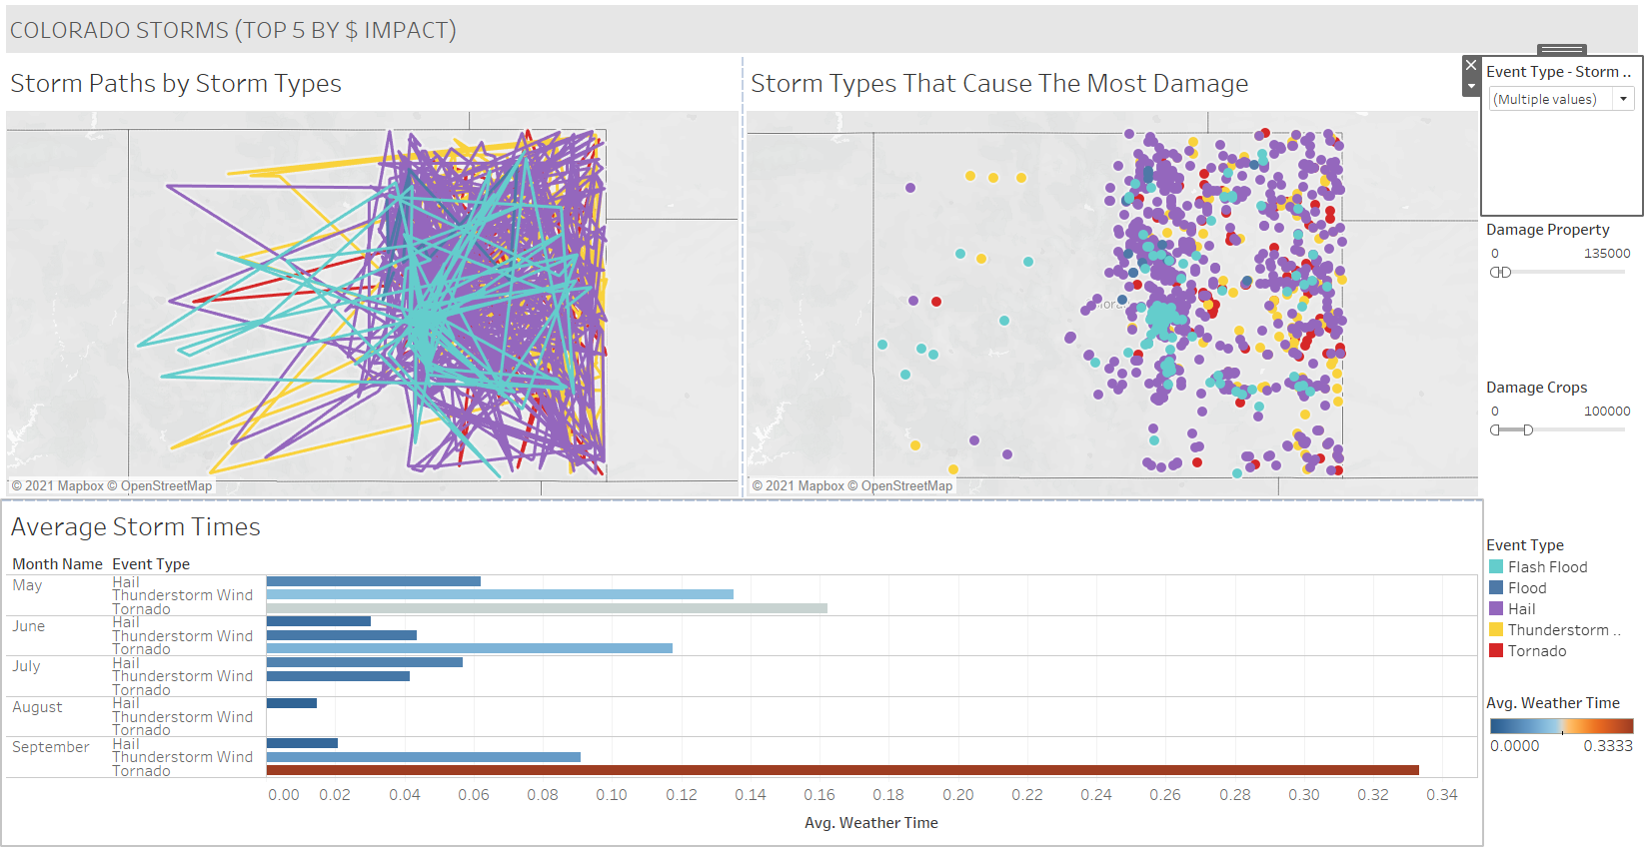

The dashboard has several sections and various functionality that will work together to help the state EMA make data driven decisions. In this user guide, I will explain the various viewpoints as well as instruct on the filtering capabilities.

The three main sections deal with storm paths, types of storms, and average storm times. By including these views, the goal was to be able to show the EMA historical information on where in the state storms of certain types typically begin, the paths they tend to follow, and how long the storms typically last. The reasoning behind this data is that it allows the EMA to deploy their assets at the appropriate times throughout the state to the appropriate areas where they can maximize their efficiencies and impact.

However, there needs to also be some drill through capability that allows the agency to focus on several key areas – each individual type of storm, as well as the damage it has caused in the past. All the filters as well as the color coding for the sheet are located along the right side in a traditional column format. This allows for all activity to be done in one area, relieving the user from trying to locate the interactive functions all over the screen.

Although I allowed for filtering on all storm types, the main view focuses on the top five storm types regarding monetary impact. The top five storm categories of floods, flash floods, hail, thunderstorms, and tornadoes account for over 90% of the financial impact in the period of the data reviewed.

Below are screenshots of the various filters I included in the capabilities of the dashboard. When filtering on type of storm, you can see it becomes much less convoluted. Also, by assigning color to each storm type, it allows you to focus in greater detail on storm type. The filters all work in conjunction on all the areas of the dashboard, so you do not need to filter each individually. The last two screenshots show filtering on property damage and crop damage. Again, this allows focus on areas where financial impact is expected.

*FILTER BY STORM TYPE:*

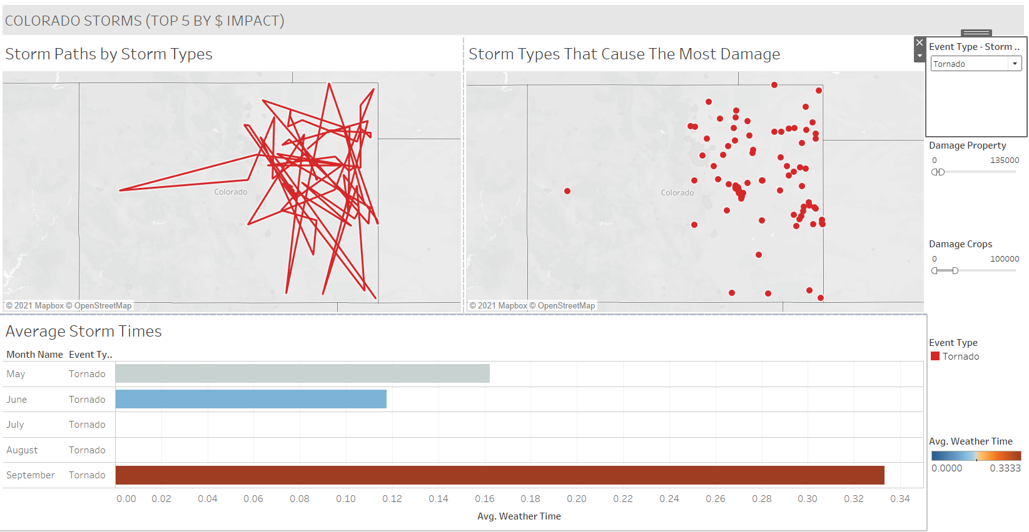

*FILTER BY PROPERTY DAMAGE:*

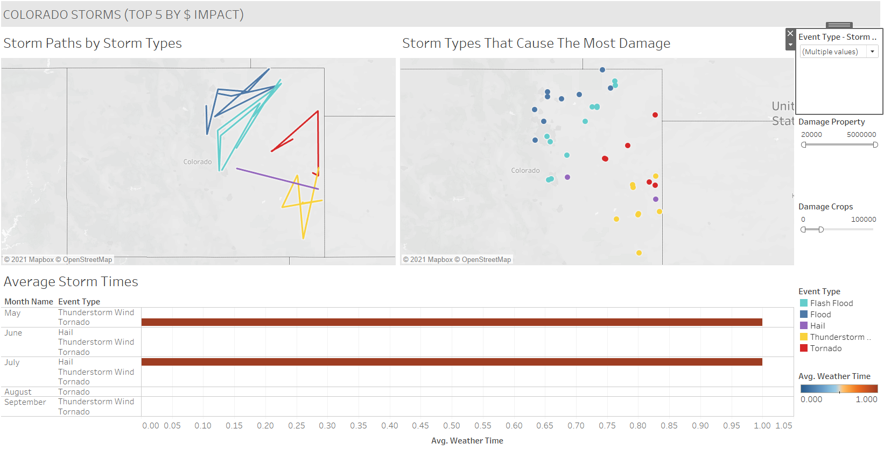

*FILTER BY CROP DAMAGE:*

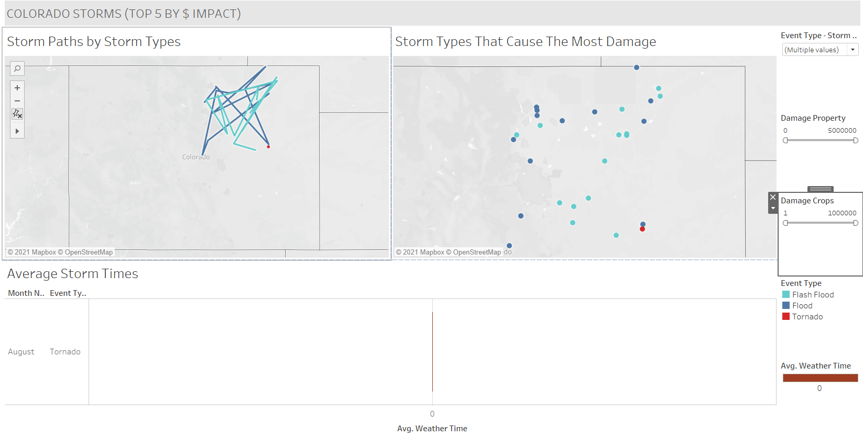

The final piece of the tool is a reference area of contact. This will be a text field (see final screenshot) providing contact information. This will be both a website and a phone number. This allows for general questions from the user to be answered either through their own research, or if a timely resolution is needed, a live person to contact. This expert can instruct on how to use the dashboard as well as help to interpret the data.

*HELP INFORMATION:*



Audience - Colorado Citizens

For this audience, a brochure containing some the following visuals with supporting text would be effective. The first visual again focuses on the largest storm type regarding monetary damage by month. This would tell the state resident historically when storms occur so they would be prepared. Some preparation tips for each storm would be handy, as tornado preparation would differ from flood preparation.

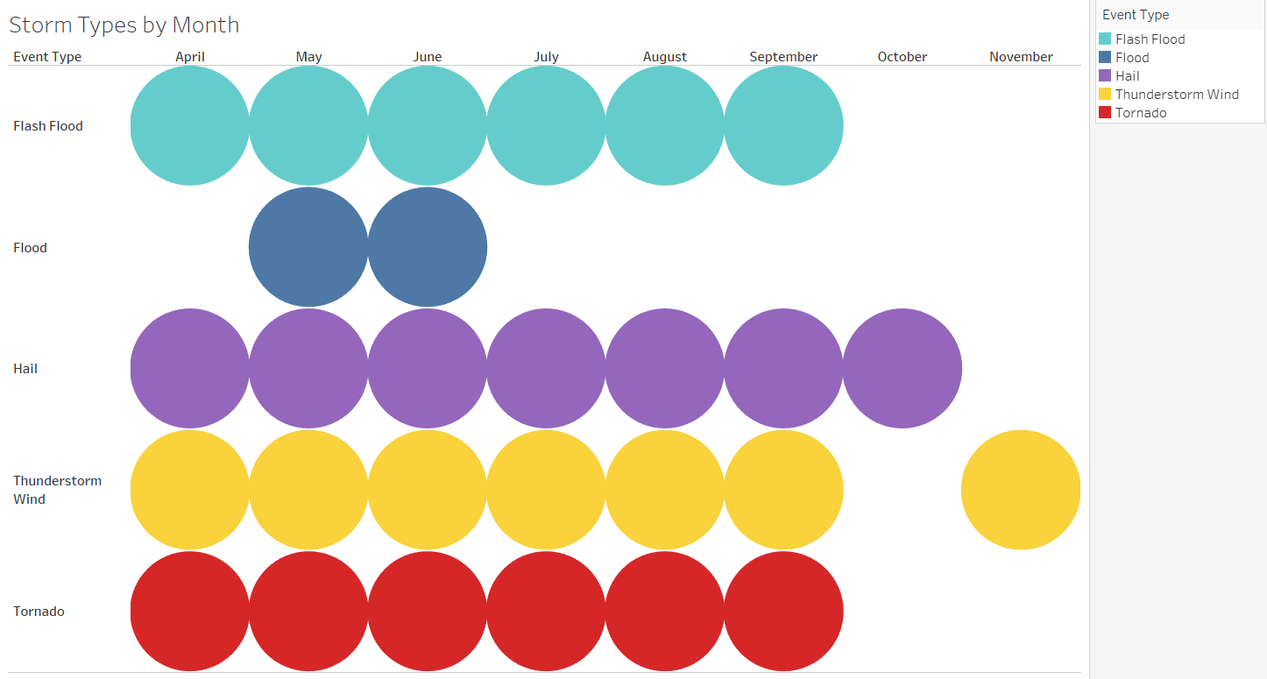

The second graph would show total deaths and injuries by storm type as well as show what storms cause the most damage. Just because a storm type causes damage, it may not be significant in comparison to other storms, increasing focus on the most damaging types. Again, this is a high-level way for the public to understand how to prepare for storms, what storms to prepare for, and when to expect them to hit.

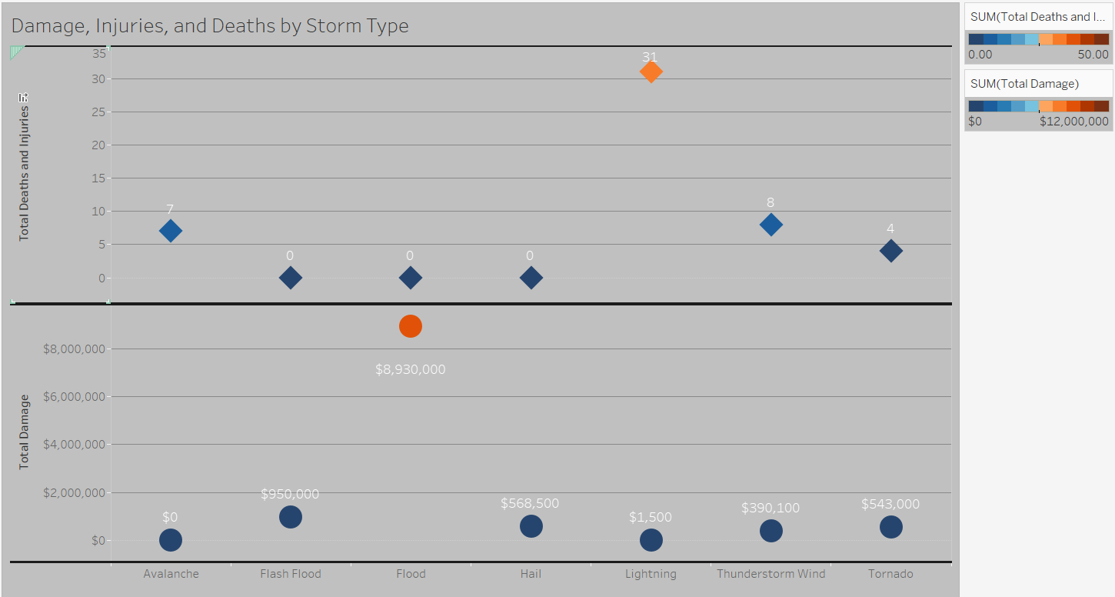

**Conclusion**

The focus of this report was ensuring the correct data was collected for the state of Colorado, then tailored to three separate audiences to ensure the most effective and engaging presentation medium for each. By reviewing who constituted each group, their level of expertise, and how they would use the method provided, I was able to accomplish that goal. Focusing on groups that would use the data the most, such as the budgeting office, the emergency management association, and the residents in general, I was able to maximize impact on weather safety in the state. Providing support for each group (contacts for questions/troubleshooting and data expertise) helps ensure a more seamless process. This framework can be followed for any data set and project.

References:

Ncei. “Storm Events Database.” *National Centers for Environmental Information*, www.ncdc.noaa.gov/stormevents/.

Yau, Nathan. *Data Points : Visualization That Means Something*, John Wiley & Sons, Incorporated, 2013.*ProQuest Ebook Central*, <https://ebookcentral-proquest-> com.ezproxy.snhu.edu/lib/snhu-ebooks/detail.action?docID=1158630.

*Tableau Community Forums*, community.tableau.com/s/explore-forums?_ga=2.22090041.327187953.1619106336-703665035.1602241505.